WIND FARM TO WEAK-GRID CONNECTION
USING UPQC CUSTOM POWER DEVICE
ABSTRACT
The location of generation facilities for wind energy is determined by wind energy resource availability, often far from high voltage (HV) power transmission grids and major consumption centers. Wind Farms (WF) employing squirrel cage induction generator (SCIG) directly connected to the grid; represent a large percentage of the wind energy conversion systems around the world. In facilities with moderated power generation, the wind farms are connected through medium voltage (MV) distribution headlines. A situation commonly found in such scheme is that the power generated is comparable to the transport capacity of the grid. This case is known as Wind Farm to Weak Grid Connection, and its main problem is the poor voltage regulation at the point of common coupling (PCC). Thus, the combination of weak grids, wind power fluctuation and system load changes produce disturbances in the PCC voltage, worsening the Power Quality and WF stability. This situation can be improved using control methods at generator level, or compensation techniques at PCC. In case of wind farms based on SCIG directly connected to the grid, is necessary to employ the last alternative. Custom power devices technology (CUPS) result very useful for this kind of application.
In recent years, the technological development of high power electronics devices has led to implementation of electronic equipment suited for electric power systems, with fast response compared to the line frequency. These active compensators allow great flexibility in: a) controlling the power flow in transmission systems using Flexible AC Transmission System (FACTS) devices, and b) enhancing the power quality in distribution systems employing Custom Power System (CUPS) devices ,The use of these active compensators to improve integration of wind energy in weak grids is the approach adopted in this work.
In this paper a compensation strategy based on a particular CUPS device, the Unified Power Quality Compensator (UPQC) has been proposed. A customized internal control scheme of the UPQC device was developed to regulate the voltage in the WF terminals, and to mitigate voltage fluctuations at grid side. The voltage regulation at WF terminal is conducted using the UPQC series converter, by voltage injection “in phase” with PCC voltage. On the other hand, the shunt converter is used to filter the WF generated power to prevent voltage fluctuations, requiring active and reactive power handling capability. The sharing of active power between converters, is managed through the common DC link. Therefore the internal control strategy is based on the management of active and reactive power in the series and shunt converters of the UPQC, and the exchange of power between converters through UPQC DC–Link. This approach increases the compensation capability of the UPQC with respect to other custom strategies that use reactive power only. The proposed compensation scheme enhances the system power quality, exploiting fully DC–bus energy storage and active power sharing between UPQC converters, features not present in DVR and D–Statcom compensators. Simulations results show the effectiveness of the proposed compensation strategy for the enhancement of Power Quality and Wind Farm stability.
- INTRODUCTION

The location of generation facilities for wind energy is determined by wind energy resource availability, often far from high voltage (HV) power transmission grids and major consumption centers [1]. In case of facilities with medium power ratings, the WF is connected through medium voltage (MV) distribution headlines. A situation commonly found in such scheme is that the power generated is comparable to the transport power capacity of the power grid to which the WF is connected, also known as weak grid connection. The main feature of this type of connections, is the increased voltage regulation sensitivity to changes in load [2]. So, the system’s ability to regulate voltage at the point of common coupling (PCC) to the electrical system is a key factor for the successful operation of the WF. Also, is well known that given the random nature of wind resources, the WF generates fluctuating electric power.These fluctuations have a negative impact on stability and power quality in electric power systems. [3] Moreover, in exploitation of wind resources, turbines employing squirrel cage induction generators (SCIG) have been used since the beginnings. The operation of SCIG demands reactive power, usually provided from the mains and/or by local generation in capacitor banks [4], [5]. In the event that changes occur in its mechanical speed, ie due to wind disturbances, so will the WF active(reactive) power injected(demanded) into the power grid, leading to variations of WF terminal voltage because of system impedance. This power disturbances propagate into the power system, and can produce a phenomenon known as “flicker”, which consists of fluctuations in the illumination level caused by voltage variations. Also, the normal operation of WF is impaired due to such disturbances. In particular for the case of “weak grids”, the impact is even
greater. In order to reduce the voltage fluctuations that may cause “flicker”, and improve WF terminal voltage regulation, several solutions have been posed. The most common one is to
upgrade the power grid, increasing the short circuit power level at the point of common coupling PCC, thus reducing the impact of power fluctuations and voltage regulation problems [5].
In recent years, the technological development of high power electronics devices has led to implementation of electronic equipment suited for electric power systems, with fast response compared to the line frequency. These active compensators allow great flexibility in: a) controlling the power flow in transmission systems using Flexible AC Transmission System (FACTS) devices, and b) enhancing the power quality in distribution systems employing Custom Power System CUPS) devices [6] [9]. The use of these active compensators to improve integration of wind energy in weak grids is the approach adopted in this work. In this paper we propose and analyze a compensation strategy using an UPQC, for the case of SCIG–based WF,
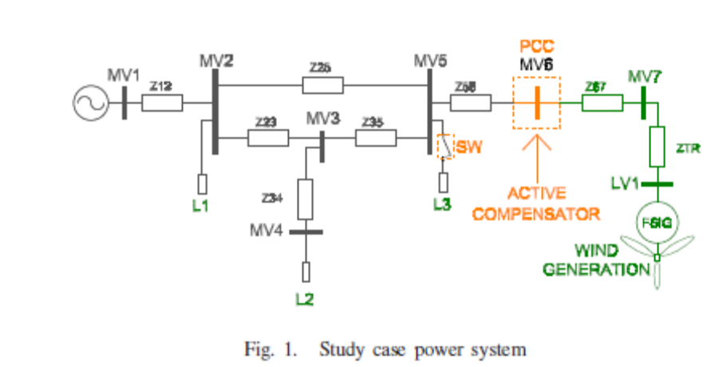
connected to a weak distribution power grid. This system is taken from a real case [7]. The UPQC is controlled to regulate the WF terminal voltage, and to mitigate voltage fluctuations at the point of common coupling (PCC), caused by system load changes and pulsating WF generated power, respectively. The voltage regulation at WF terminal is conducted using the UPQC series converter, by voltage injection “in phase” with PCC voltage. On the other hand, the shunt converter is used to filter the WF generated power to prevent voltage fluctuations, requiring active and reactive power handling capability. The sharing of active power between converters, is managed through the common DC link. Simulations were carried out to demonstrate the effectiveness of the proposed compensation approach.

Wind Energy
Wind power:
Wind is abundant almost in any part of the world. Its existence in nature caused by uneven heating on the surface of the earth as well as the earth’s rotation means that the wind resources will always be available. The conventional ways of generating electricity using non renewable resources such as coal, natural gas, oil and so on, have great impacts on the environment as it contributes vast quantities of carbon dioxide to the earth’s atmosphere which in turn will cause the temperature of the earth’s surface to increase, known as the green house effect. Hence, with the advances in science and technology, ways of generating electricity using renewable energy resources such as the wind are developed. Nowadays, the cost of wind power that is connected to the grid is as cheap as the cost of generating electricity using coal and oil. Thus, the increasing popularity of green electricity means the demand of electricity produced by using non renewable energy is also increased accordingly.

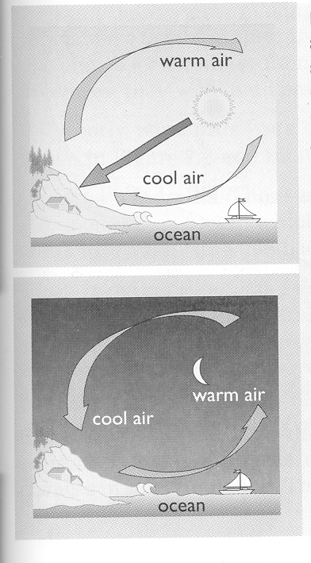

Fig: Formation of wind due to differential heating of land and sea
Features of wind power systems:

There are some distinctive energy end use features of wind power systems

- Most wind power sites are in remote rural, island or marine areas. Energy requirements in such places are distinctive and do not require the high electrical power.
- A power system with mixed quality supplies can be a good match with total energy end use i.e. the supply of cheap variable voltage power for heating and expensive fixed voltage electricity for lights and motors.
- Rural grid systems are likely to be weak (low voltage 33 KV). Interfacing a Wind Energy Conversion System (WECS) in weak grids is difficult and detrimental to the workers’ safety.
- There are always periods without wind. Thus, WECS must be linked energy storage or parallel generating system if supplies are to be maintained.

Power from the Wind:

Kinetic energy from the wind is used to turn the generator inside the wind turbine to produced electricity. There are several factors that contribute to the efficiency of the wind turbine in extracting the power from the wind. Firstly, the wind speed is one of the important factors in determining how much power can be extracted from the wind. This is because the power produced from the wind turbine is a function of the cubed of the wind speed. Thus, the wind speed if doubled, the power produced will be increased by eight times the original power. Then, location of the wind farm plays an important role in order for the wind turbine to extract the most available power form the wind.
The next important factor of the wind turbine is the rotor blade. The rotor blades length of the wind turbine is one of the important aspects of the wind turbine since the power produced from the wind is also proportional to the swept area of the rotor blades i.e. the square of the diameter of the swept area.
Hence, by doubling the diameter of the swept area, the power produced will be four fold increased. It is required for the rotor blades to be strong and light and durable . As the blade length increases, these qualities of the rotor blades become more elusive. But with the recent advances in fiberglass and carbon-fiber technology, the production of lightweight and strong rotor blades between 20 to 30 meters long is possible. Wind turbines with the size of these rotor blades are capable to produce up to 1 megawatt of power.

The relationship between the power produced by the wind source and the velocity of the wind and the rotor blades swept diameter is shown below.

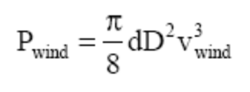

The derivation to this formula can be looked up in [2]. It should be noted that some books derived the formula in terms of the swept area of the rotor blades (A) and the air density is denoted as δ .
Thus, in selecting wind turbine available in the market, the best and efficient wind turbine is the one that can make the best use of the available kinetic energy of the wind.

Wind power has the following advantages over the traditional power plants.
-  Improving price competitiveness,
-  Modular installation,
-  Rapid construction,
-  Complementary generation,
-  Improved system reliability, and
-  Non-polluting.

Wind Turbines:

There are two types of wind turbine in relation to their rotor settings. They are:
-  Horizontal-axis rotors, and
-  Vertical-axis rotors.
In this report, only the horizontal-axis wind turbine will be discussed since the modeling of the wind driven electric generator is assumed to have the horizontal-axis rotor.

The horizontal-axis wind turbine is designed so that the blades rotate in front of the tower with respect to the wind direction i.e. the axis of rotation are parallel to the wind direction. These are generally referred to as upwind rotors. Another type of horizontal axis wind turbine is called downwind rotors which has blades rotating in back of the tower. Nowadays, only the upwind rotors are used in large-scale power generation and in this report, the term .horizontal-axis wind turbine refers to the upwind rotor arrangement.

The main components of a wind turbine for electricity generation are the rotor, the transmission system, the generator, and the yaw and control system. The following figures show the general layout of a typical horizontal-axis wind turbine, different parts of the typical grid-connected wind turbine, and cross-section view of a nacelle of a wind turbine

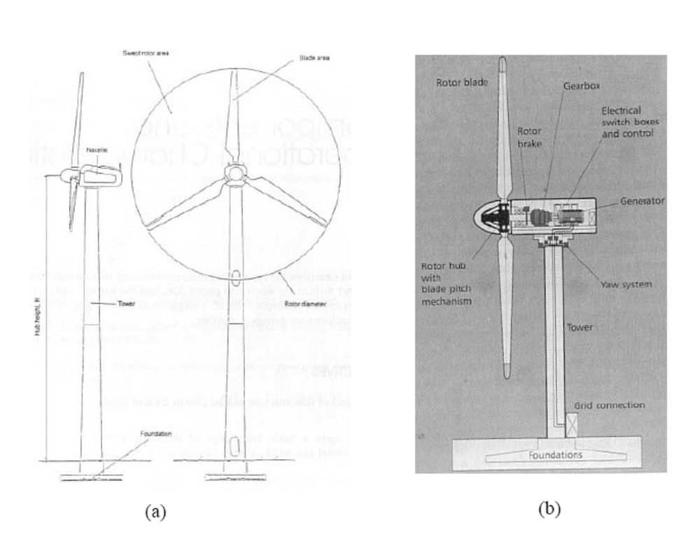

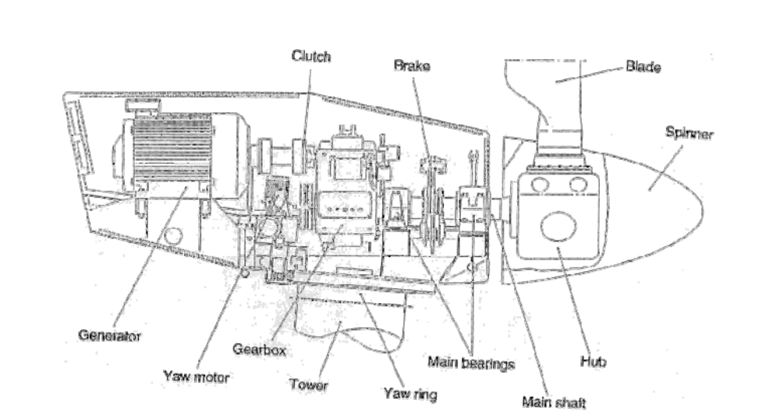
(c)

Figs: (a) Main Components of Horizontal-axis Wind Turbine
(b) Cross-section of a Typical Grid-connected Wind Turbine
(c) Cross-section of a Nacelle in A Grid-connected Wind Turbine

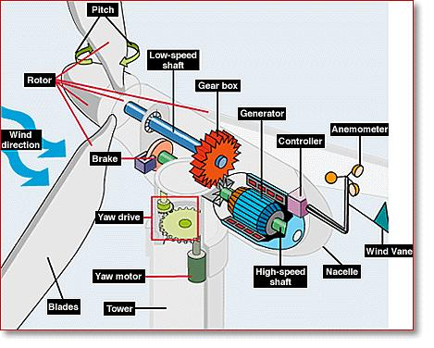

The main components of a wind turbine can be classified as i) Tower ii) Rotor system iii) Generator iv) Yaw v) Control system and vi) Braking and transmission system

(i) Tower:

It is the most expensive element of the wind turbine system. The lattice or tubular types of towers are constructed with steel or concrete. Cheaper and smaller towers may be supported by guy wires. The major components such as rotor brake, gearbox, electrical switch boxes, controller, and generator are fixed on to or inside nacelle, which can rotate or yaw according to wind direction, are mounted on the tower. The tower should be designed to withstand gravity and wind loads. The tower has to be supported on a strong foundation in the ground. The design should consider the resonant frequencies of the tower do not coincide with induced frequencies from the rotor and methods to damp out if any. If the natural frequency of the tower lies above the blade passing frequency, it is called stiff tower and if below is called soft tower.

(ii) Rotor:

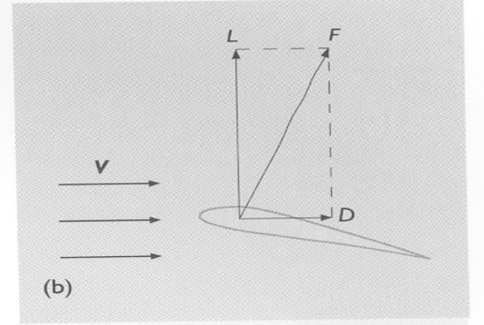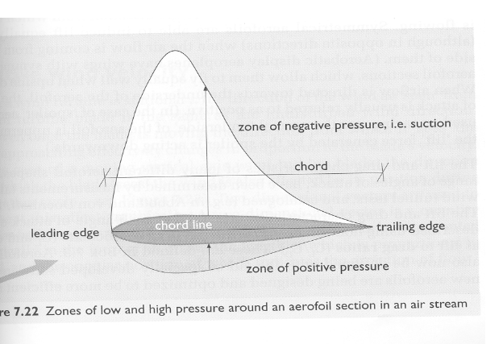The aerodynamic forces acting on a wind turbine rotor is explained by aerofoil theory. When the aerofoil moves in a flow, a pressure distribution is established around the symmetric aerofoil shown in Fig (a).

A reference line from which measurements are made on an aerofoil section is referred to as chord line and the length is known as chord. The angle, which an aerofoil makes with the direction of airflow measured against the chord line is called the angle of attack. The generation of lift force on an aerofoil placed at an angle of attack to an oncoming flow is a consequence of the distortion of the streamlines of the fluid passing above and below the aerofoil. When a blade is subjected to unperturbed wind flow, the pressure decreases towards the center of curvature of a streamline. The consequence is the reduction of pressure (suction) on the upper surface of the aerofoil compared to ambient pressure, while on the lower side the pressure is positive or greater. The pressure difference results in lift force responsible for rotation of the blades. The drag force is the component that is in line with the direction of oncoming flow is shown in Fig (b).
Fig (a) Zones of low and high-pressure (b) Forces acting on the rotor blade

These forces are both proportional to the energy in the wind. To attain a high efficiency of rotor in wind turbine design is for the blade to have a relatively high lift-to-drag ratio. This ratio can be varied along the length of the blade to optimize the turbine’s energy output at various wind speeds. The lift force, drag force or both extract the energy from wind. For aerofoil to be aerodynamically efficient, the lift force can be 30 times greater than the drag force.
Cambered or asymmetrical aerofoils have curved chord lines. The chord line is now defined as the straight line joining the ends of the camber line and is measured from this chord line. Cambered aerofoil is preferred to symmetrical aerofoil because they have higher lift/drag ratio for positive angles of attack. It is observed that the lift at zero angle of attack is no longer zero and that the zero lift occurs at a small negative angle of attack of approximately º. The center of pressure, which is at the ¼ chord position on symmetrical aerofoil has at the ¼ chord position on cambered aerofoil and moves towards the trailing edge with increasing angle of attack.

Arching or cambering a flat plate will cause it to induce higher lift force for a given angle of attack and blades with a cambered plate profile work well, under the conditions experienced by high solidity, multi bladed wind turbines. For low solidity turbines, the use of aerofoil section is more effective.
The characteristics of an aerofoil, the angle of attack, the magnitude of the relative wind speed are the prime parameters responsible for the lift and drag forces. These forces acting on the blades of a wind turbine rotor are transformed into a rotational torque and axial thrust force. The useful work is produced by the torque where as the thrust will overturn the turbine. This axial thrust should be resisted by the tower and foundations.

Rotor speed:

Low speed and high-speed propeller are the two types of rotors. A large design tip speed ratio would require a long, slender blade having high aspect ratio. A low design tip speed would require a short, flat blade. The low speed rotor runs with high torque and the high-speed rotor runs with low torque. The wind energy converters of the same size have essentially the same power output, as the power output depends on rotor area. The low speed rotor has curved metal plates. The number of blades, weight, and difficulty of balancing the blades makes the rotors to be typically small. They get self-started because of their aerodynamic characteristics. The propeller type rotor comprises of a few narrow blades with more sophisticated airfoil section. When not working, the blades are completely stalled and the rotor cannot be self-started. Therefore, propeller type rotors should be started either by changing the blade pitch or by turning the rotor with the aid of an external power source (such as generator used as a motor to turn the rotor). Rotor is allowed to run at variable speed or constrained to operate at a constant speed. When operated at variable speed, the tip speed ratio remains constant and aerodynamic efficiency is increased.

Rotor alignment:
The alignment of turbine blades with the direction of wind is made by upwind or downwind rotors. Upwind rotors face the wind in front of the vertical tower and have the advantage of somewhat avoiding the wind shade effect from the presence of the tower. Upwind rotors need a yaw mechanism to keep the rotor axis aligned with the direction of the wind. Downwind rotors are placed on the lee side of the tower. A great disadvantage in this design is the fluctuations in the wind power due to the rotor passing through the wind shade of the tower which gives rise to more fatigue loads. Downwind rotors can be built without a yaw mechanism, if the rotor and nacelle can be designed in such a way that the nacelle will follow the wind passively. This may however include gyroscopic loads and hamper the possibility of unwinding the cables when the rotor has been yawing passively in the same direction for a long time, thereby causing the power cables to twist. Upwind rotors need to be rather inflexible to keep the rotor blades clear of the tower, downwind rotors can be made more flexible. The latter implies possible savings with respect to weight and may contribute to reducing the loads on the tower. The vast majority of wind turbines in operation today have upwind rotors.

Number of rotor blades:

The three bladed rotors are the most common in modern aero generators. Compared to three bladed concepts, the two and one bladed concepts have the advantage of representing a possible saving in relation to cost and weight of the rotor. However, the use of fewer rotor blades implies that a higher rotational speed or a larger chord is needed to yield the same energy output as a three bladed turbine of a similar size. The use of one or two blades will also result in more fluctuating loads because of the variation of the inertia, depending on the blades being in horizontal or vertical position and on the variation of wind speed when the blade is pointing upward or downward.
Therefore, the two and one bladed concepts usually have so-called teetering hubs, implying that they have the rotor hinged to the main shaft. This design allows the rotor to teeter in order to eliminate some of the unbalanced loads. One bladed wind turbines are less widespread than two–bladed turbines. This is because they in addition to a higher rotational speed, more noise and visual intrusion problems, need a counter weight to balance the rotor blade.

(iv)Generator:

Electricity is an excellent energy vector to transmit the high quality mechanical power of a wind turbine. Generator is usually 95% efficient and transmission losses should be less than 10%. The frequency and voltage of transmission need not be standardized, since the end use requirements vary. There are already many designs of wind/ electricity systems including a wide range of generators. The distinctive features of wind/electricity generating systems are:

- Wind turbine efficiency is greatest if rotational frequency varies to maintain constant tip speed ratio, yet electricity generation is most efficient at constant or near constant frequency.

- Mechanical control of turbine to maintain constant frequency increases complexity and expense. An alternative method, usually cheaper and more efficient is to vary the electrical load on the turbine to control the rotational frequency.

- The optimum rotational frequency of a turbine in a particular wind speed decreases with increase in radius in order to maintain constant tip speed ratio. Thus, only small turbines of less than 2 m radius can be coupled directly to generators. Larger machines require a gearbox to increase the generator drive frequency.

- Gearboxes are relatively expensive and heavy. They require maintenance and can be noisy. To overcome this problem, generators with a large number of poles are being manufactured to operate at lower frequency.

- The turbine can be coupled with the generator to provide an indirect drive through a mechanical accumulator (weight lifted by hydraulic pressure) or chemical storage (battery). Thus, generator control is independent of turbine operation.

The generators used with wind machines are i) Synchronous AC generator ii) Induction AC generator and iii) Variable speed generator

Synchronous AC generator:

The Synchronous speed will be in the range of 1500 rpm – 4 pole, 1000 rpm – 6 pole or 750 rpm, - 8 pole for connection to a 50 Hz net work. The ingress of moisture is to be avoided by providing suitable protection of the generator. Air borne noise is reduced by using liquid cooling in some wind turbines. An increase of the damping in the wind turbine drive train at the expense of losses in the rotor can be obtained by high slip at rated power output. Synchronous generators run at a fixed or synchronous speed, 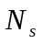. We have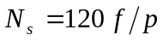, where is the number of poles,  is the electrical frequency and is the speed in rpm.

Induction AC generator:

They are identical to conventional industrial induction motors and are used on constant speed wind turbines. The torque is applied to or removed from the shaft if the rotor speed is above or below synchronous. The power flow direction in wires is the factor to be considered to differentiate between a synchronous generator and induction motor. Some design modifications are to be incorporated for induction generators considering the different operating regime of wind turbines and the need for high efficiency at part load, etc.

Variable speed generator:

Electrical variable speed operation can be approached as:
  - All the output power of the wind turbine may be passed through the frequency converters to give a broad range of variable speed operation.
  - A restricted speed range may be achieved by converting only a fraction of the output power.

(v) Yaw system:

It turns the nacelle according to the actuator engaging on a gear ring at the top of the tower. Yaw control is the arrangement in which the entire rotor is rotated horizontally or yawed out of the wind. During normal operation of the system, the wind direction should be perpendicular to the swept area of the rotor. The yaw drive is controlled by a slow closed- loop control system. The yaw drive is operated by a wind vane, which is usually mounted on the top of the nacelle sensing the relative wind direction, and the wind turbine controller. In some designs, the nacelle is yawed to attain reduction in power during high winds.
In extremity, the turbine can be stopped with nacelle turned such that the rotor axis is at right angles to the wind direction. One of the more difficult parts of a wind turbine designs is the yaw system, though it is apparently simple. Especially in turbulent wind conditions, the prediction of yaw loads is uncertain.

(vi) Control systems:

A wind turbine power plant operates in a range of two characteristic wind speed values referred to as Cut in wind speed 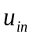 and Cut out wind speed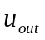. The turbine starts to produce power at Cut in wind speed usually between 4 and 5 m/s. Below this speed, the turbine does not generate power. The turbine is stopped at Cut out wind speed usually at 25 m/s to reduce load and prevent damage to blades. They are designed to yield maximum power at wind speeds that lies usually between 12 and 15 m/s. It would not be economical to design turbines at strong winds, as they are too rare. However, in case of stronger winds, it is necessary to waste part of the excess energy to avoid damage on the wind turbine. Thus, the wind turbine needs some sort of automatic control for the protection and operation of wind turbine. The functional capabilities of the control system are required for:

- Controlling the automatic startup
- Altering the blade pitch mechanism
- Shutting down when needed in the normal and abnormal condition
- Obtaining information on the status of operation, wind speed, direction and power production for monitoring purpose

As can be seen in figure 1 (c), the nacelle consists of several components. They are the generator, yaw motor, gearbox, tower, yaw ring, main bearings, main shaft, hub, blade, clutch, brake, blade and spinner. Other equipment that is not shown in the figure might include the anemometer, the controller inside the nacelle, the sensors and so on. The generator is responsible for the conversion of mechanical to electrical energy.
Yaw motor is used power the yaw drive to turn the nacelle to the direction of the wind. The gearbox is used to connect the low-speed shaft (main shaft in the figure) to the high-speed shaft which drives the generator rotor. The brake is used to stop the main shaft from over speeding. The blades are used to extract the kinetic power from the wind to mechanical power i.e. lifting and rotating the blades. The tower is made from tubular steel or steel lattice and it is usually very high in order to expose the rotor blades to higher wind speed.
Induction generator:
An induction generator is a type of electrical generator that is mechanically and electrically similar to a polyphase induction motor. Induction generators produce electrical power when their shaft is rotated faster than the synchronous frequency of the equivalent induction motor. Induction generators are often used in wind turbines and some micro hydro installations due to their ability to produce useful power at varying rotor speeds. Induction generators are mechanically and electrically simpler than other generator types. They are also more rugged, requiring no brushes or commutators.
Induction generators are not self-exciting, meaning they require an external supply to produce a rotating magnetic flux. The external supply can be supplied from the electrical grid or from the generator itself, once it starts producing power. The rotating magnetic flux from the stator induces currents in the rotor, which also produces a magnetic field. If the rotor turns slower than the rate of the rotating flux, the machine acts like an induction motor. If the rotor is turned faster, it acts like a generator, producing power at the synchronous frequency.
In induction generators the magnetizing flux is established by a capacitor bank connected to the machine in case of stand alone system and in case of grid connection it draws magnetizing current from the grid. It is mostly suitable for wind generating stations as in this case speed is always a variable factor.

Why Induction Generator:
Induction generator is commonly used in the wind turbine electric generation due to its reduced unit cost, brushless rotor construction, ruggedness, and ease of Maintenance. Moreover, induction generators have several characteristics over the synchronous generator. The speed of the asynchronous generator will vary according to the turning force (moment, or torque) applied to it. In real life, the difference between the rotational speed at peak power and at idle is very small approximately 1 percent. This is commonly referred as the generator’s slip which is the difference between the synchronous speed of the induction generator and the actual speed of the rotor.

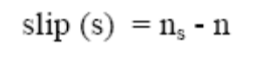

This speed difference is a very important variable for the induction machine. The term slip is used because it describes what an observer riding with the stator field sees looking at the rotor which appears to be slipping backward [35]. A more useful form of the slip quantity results when it is expressed on a per unit basis using synchronous speed as the reference. The expression of the slip in per unit is shown below.
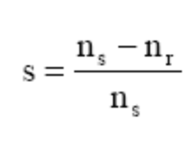
A four-pole, 50 Hz generator will run idle at 1500 rpm according to the following formula.

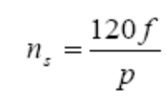
If the generator is producing its maximum power, it will be running at 1515 rpm. A useful mechanical property of the generator is that it will increase or decrease its speed slightly if the torque varies and hence will be less tear and wear on the gearbox as well as in the system. This is one of the important reasons to use asynchronous (induction) generator compared to a synchronous generator on a wind turbine.

Induction Machine Analysis
The following figure shows the torque vs speed characteristic of typical squirrel cage induction machine.

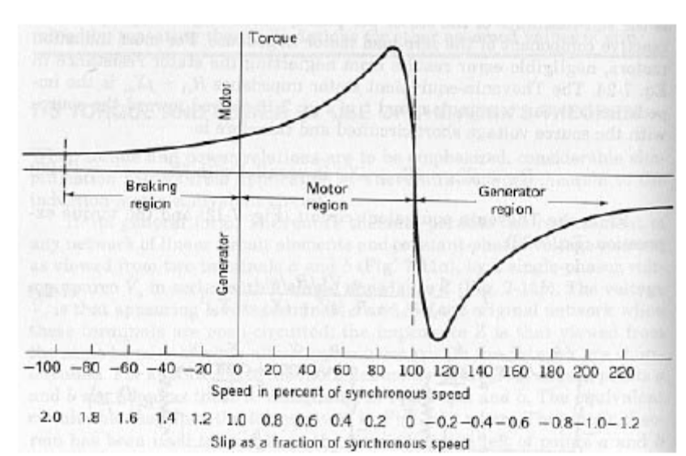

Fig: Torque vs. Speed Characteristics of Squirrel-cage Induction Generator
In the figure, it can be seen that when the induction machine is running at Synchronous speed at the point where the slip is zero i.e. the rotor is spinning at the same speed as the rotating magnetic field of the stator, the torque of the machine is zero. If the induction machine is to be operated as a motor, the machine is to operated just below its synchronous speed.
On the other hand, if the induction machine is to be operated as a generator, its stator terminals should be connected to a constant-frequency voltage source and its rotor is driven above synchronous speed (s<0) by a prime mover such as the wind turbine shaft. The source fixes the synchronous speed and supplies the reactive power input required exciting the air gap magnetic field and hence the slip is negative.

The following figure shows the per-phase equivalent circuit of the induction machine.

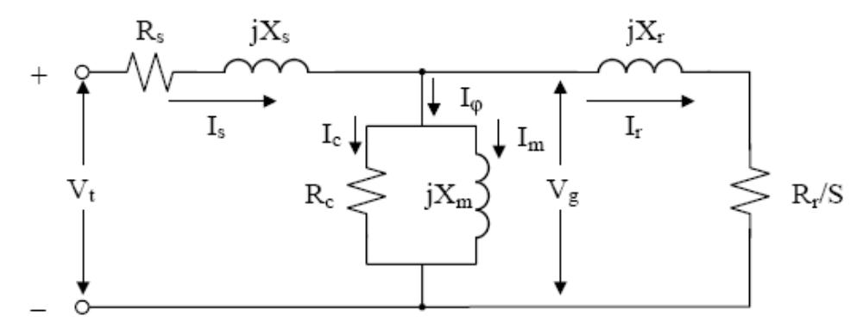

Fig. : Per-Phase Equivalent Circuit of An Induction Machine

In this project, star-connected induction machine is evaluated. All the calculations are in per-phase values. Hence, for a star-connected stator:

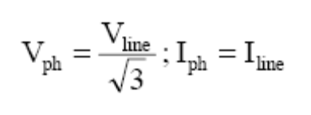

In order to analyze the behavior of an induction generator, the operation of an Induction motor must be fully understood. Once, the equivalent circuit parameters have been obtained, the performance of an induction motor is easy to determine. As shown in Fig, the total power Pg transferred across the air gap from the stator is

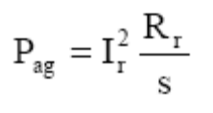

And it is evident from figure 3 that the total rotor loss Prloss is

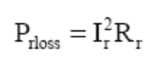

Therefore, the internal mechanical power developed by the motor is

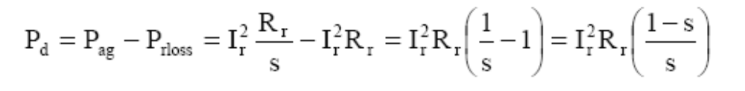

From the power point of view, the equivalent circuit of figure 3 can be rearranged to the following figure, where the mechanical power per stator phase is equal to the power absorbed by the resistance R2(1-s)/s.

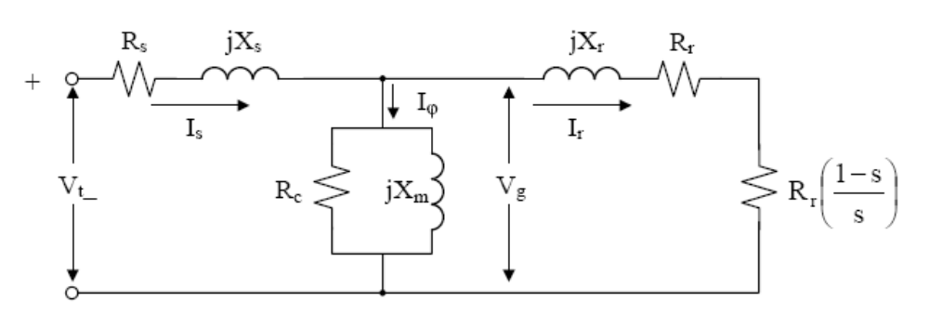

Fig: Alternative Form for Per-Phase Equivalent Circuit

The analysis of an induction motor is also facilitated by using the power flow diagram as shown in the following figure in conjunction with the equivalent circuit.

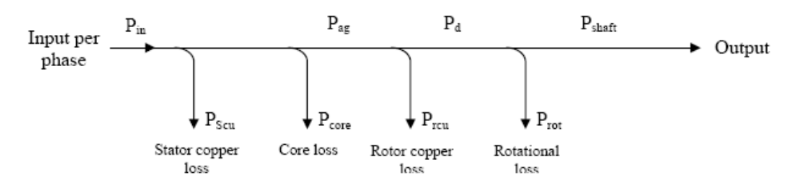

Fig: Power Flow Diagram

Where,
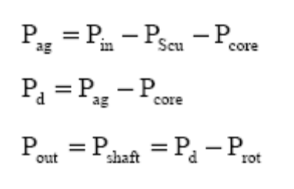
The parameters of an induction generator can be determined by using the no-load test and block rotor test (The steps in calculating the parameters and the test results obtained from a 440V, 4.6A, 2.2kW induction motor ).
UNIFIED POWER QUALITY CONDITIONER
The provision of both DSTATCOM and DVR can control the power quality of the source current and the load bus voltage. In addition, if the DVR and STATCOM are connected on the DC side, the DC bus voltage can be regulated by the shunt connected DSTATCOM while the DVR supplies the required energy to the load in case of the transient disturbances in source voltage. The configuration of such a device (termed as Unified Power Quality Conditioner (UPQC)) is shown in Fig. 14.15. This is a versatile device similar to a UPFC. However, the control objectives of a UPQC are quite different from that of a UPFC.

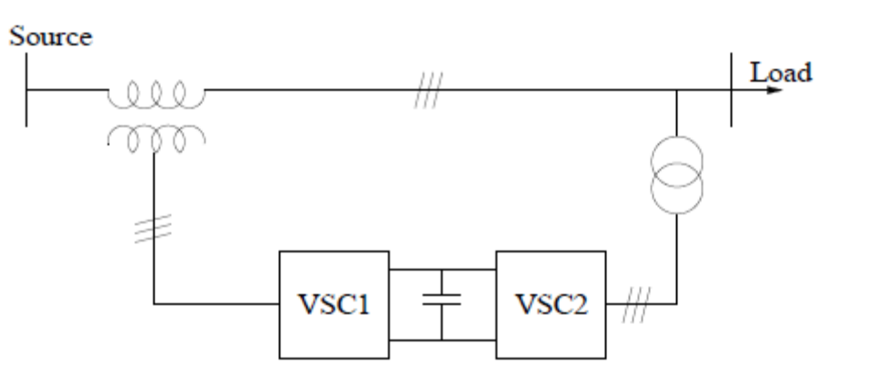

CONTROL OBJECTIVES OF UPQC
The shunt connected converter has the following control objectives
1. To balance the source currents by injecting negative and zero sequence components required by the load
2. The compensate for the harmonics in the load current by injecting the required harmonic currents
3. To control the power factor by injecting the required reactive current (at fundamental frequency)
4. To regulate the DC bus voltage.
The series connected converter has the following control objectives
1. To balance the voltages at the load bus by injecting negative and zero sequence voltages to compensate for those present in the source.
2. To isolate the load bus from harmonics present in the source voltages, by injecting the harmonic voltages
3. To regulate the magnitude of the load bus voltage by injecting the required active and reactive components (at fundamental frequency) depending on the power factor on the source side
4. To control the power factor at the input port of the UPQC (where the source is connected. Note that the power factor at the output port of the UPQC (connected to the load) is controlled by the shunt converter.
Operation of UPQC
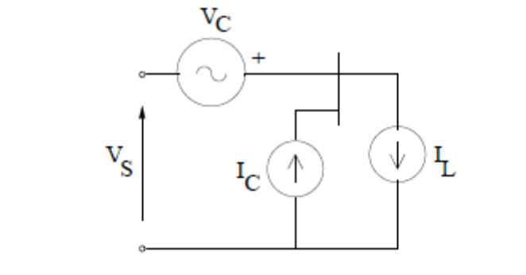
The operation of a UPQC can be explained from the analysis of the idealized equivalent circuit shown in Fig. 14.16. Here, the series converter is represented by a voltage source VC and the shunt converter is represented by a current source IC. Note that all the currents and voltages are 3 dimensional vectors with phase coordinates. Unlike in the case of a UPFC (discussed in chapter 8), the voltages and currents may contain negative and zero sequence components in addition to harmonics. Neglecting losses in the converters, we get the relation
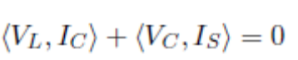
Where X,Ydenote the inner product of two vectors, defined by
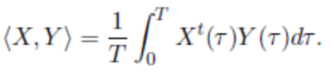
Let the load current IL and the source voltage VS be decomposed into two
Components given by
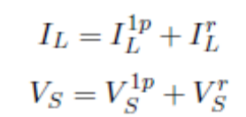
Where I1p L contains only positive sequence, fundamental frequency components Similar comments apply to V 1pS. IrL and V rS contain rest of the load current and the source voltage including harmonics. I1pL is not unique and depends on the power factor at the load bus. However, the following relation applies for I1p L .
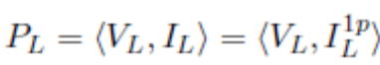
This implies that hIrL ; VLi = 0. Thus, the fundamental frequency, positive sequence component in IrL does not contribute to the active power in the load. To meet the control objectives, the desired load voltages and source currents must contain only positive sequence, fundamental frequency components and
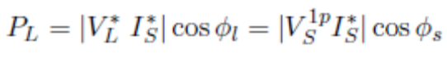
Where V ¤ L and I¤S are the reference quantities for the load bus voltage and the source current respectively. Ál is the power factor angle at the load bus while Ás is the power factor angle at the source bus (input port of UPQC). Note that V ¤ L(t) and I¤S (t) are sinusoidal and balanced. If the reference current (I¤C ) of the shunt converter and the reference voltage (V ¤ C) of the series converter are chosen as
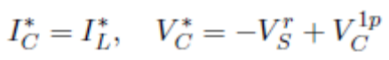
With the constraint
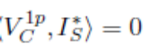
We have,
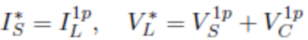
Note that the constraint (14.30) implies that V 1p C is the reactive voltage in quadrature with the desired source current, I¤S . It is easy to derive that 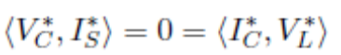 The above equation shows that for the operating conditions assumed, a UPQC can be viewed as a inaction of a DVR and a STATCOM with no active power °ow through the DC link. However, if the magnitude of V ¤ L is to be controlled, it may not be feasible to achieve this by injecting only reactive voltage. The situation gets complicated if V 1p S is not constant, but changes due to
system disturbances or fault. To ensure the regulation of the load bus voltage it may be necessary to inject variable active voltage (in phase with the source current). If we express
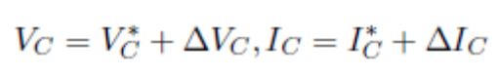

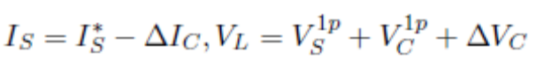
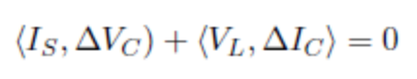
In deriving the above, we assume that
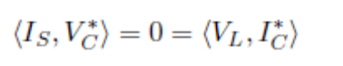
This implies that both ¢VC and ¢IC are perturbations involving positive sequence, fundamental frequency quantities (say, resulting from symmetric voltage sags). the power balance on the DC side of the shunt and series converter. The perturbation in VC is initiated to ensure that
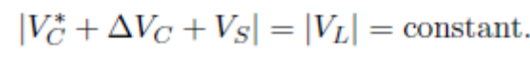
Thus, the objective of the voltage regulation at the load bus may require exchange of power between the shunt and series converters.

Remarks:
1. The unbalance and harmonics in the source voltage can arise due to uncompensated nonlinear and unbalanced loads in the upstream of the UPQC.

2. The injection of capacitive reactive voltage by the series converter has the advantage of raising the source voltage magnitude.

Voltage Fluctuations
Although blackouts seem to get all the attention, major power problems can be attributed to voltage fluctuations such as sags, surges and impulses. Thus, it is not surprising that users tend to overlook this issue and do not pay much attention to protection against invisible voltage fluctuations. The majority of users believe uninterruptible power supply (UPS) systems are a universal remedy for all power-related problems. The end result is a modest market for voltage regulators used to regulate the ac from the outlet. A recent study conducted by research firm Frost & Sullivan reveals this market generated worldwide revenue of only $203.3 million in 2003, and is expected to grow at an average annual growth rate of 4.5% over next few years. At this rate, it is estimated to reach $277.7 million by 2010.
By comparison, UPS is expected to grow from $4.7 billion in 2003 to $6.3 billion, according to Venture Development Corp. Although, this market has also suffered because of recent economic conditions and cuts in spending, the global awareness of the benefits of power protection and recovery in the market is expected to improve revenues in the coming years.
According to Frost & Sullivan Research Analyst G.V.Suryanarayana Raju, “To boost voltage regulator usage, suppliers must conduct consumer awareness campaigns and educate the users about the damages caused by voltage fluctuation frequency to the end equipment connected to the supply.” He adds that 95% of power problems can be attributed to voltage fluctuations such as sags, surges and impulses and only 5% to blackouts. Although UPS systems offer some sort of regulation, it is not sufficient. Hence, users must combine UPS with precise voltage regulators to effectively tackle blackouts and voltage fluctuations on the supply line, recommends Raju.
Furthermore, the report indicates that of the three major technologies—tap switching, ferro resonant and buck-boost—tap switching offers growth potential. In 2003, tap switching-based solutions accounted for nearly 63% of the market revenues. Due to its faster response and ease of manufacturing, it is also finding new uses in contemporary high-speed electronic applications. Tap switching products are becoming popular for mining and petroleum exploration activities in Africa and South America.
While ferro resonant and buck-boost technologies have several drawbacks, they offer some good properties. Ferro resonant, for instance, has improved isolation and noise attenuation properties. Most notably, buck-boost provides stability and efficiency in high-power applications.
The study shows that the growth for these products will come from developing nations where the main power supply is highly unstable. “The highly unstable main power supply in Asia and the rest-of-world necessitates installation of additional external protection in the form of voltage regulators,” notes Raju. Developing nations need to improve power quality and, in turn, increase demand for voltage regulator products. In 2003, Asia, including Japan, accounted for 25% of the world voltage regulator market. Much higher figures are projected for next few years.
Meanwhile, new voltage regulating products are being created using IGBT technology for its improved stability and protection properties against voltage fluctuations in high-power electronic devices. Once consumers are convinced of IGBT’s ability to shield equipment with isolation and fast response features, this market is expected to drive upward.
Weak grid
The term ‘weak grid’ is used in many connections both with and without the inclusion of wind energy. It is used without any rigour definition usually just taken to mean the voltage level is not as constant as in a ‘stiff grid’. Put this way the definition of a weak grid is a grid where it is necessary to take voltage level and fluctuations into account because there is a probability that the values might exceed the requirements in the standards when load and production cases are considered. In other words, the grid impedance is significant and has to be taken into account in order to have valid conclusions. Weak grids are usually found in more remote places where the feeders are long and operated at a medium voltage level. The grids in these places are usually designed for relatively small loads. When the design load is exceeded the voltage level will be below the allowed minimum and/or the thermal capacity of the grid will be exceeded. One of the consequences of this is that development in the region with this weak feeder is limited due to the limitation in the maximum power that is available for industry etc. The problem with weak grids in connection with wind energy is the opposite. Due to the impedance of the grid the amount of wind energy that can be absorbed by the grid at the point of connection is limited because of the upper
voltage level limit. So in connection with wind energy a weak grid is a power supply system where the amount of wind energy that can be absorbed is limited by the grid capacity and not e.g. by operating limits of the conventional generation.
Basic power control idea

The basic power control idea investigated in the current project is to buffer wind energy in situations where the grid voltage would otherwise exceed the limit and then release at a later time when the voltage of the grid is lower. The main idea is to combine a wind farm with an energy storage and a control
system and then be able to connect a larger amount of wind capacity without exceeding the voltage limits and without grid re-enforcement and still have a profitable wind energy system.
  - Outline of report

The report initially presents the basic problem with wind turbines in weak grids in some details. It then continues with a detailed presentation of the power control concept and various ways of implementing such concepts. This includes discussions on different storage technologies and control strategies. Then a
framework for assessing power control options (in both technical and economic terms) as a mean of integrating more wind energy is presented. A simulation model for assessing the voltage level, amount of wind energy and storage size has been developed as part of the project and it is described in some details. The report ends with a short indication of the size, performance and cost associated with power control concepts as a solution to wind energy integration in weak grids.

2 Basic Problems with Wind Turbines in Weak Grids
2.1 Voltage level
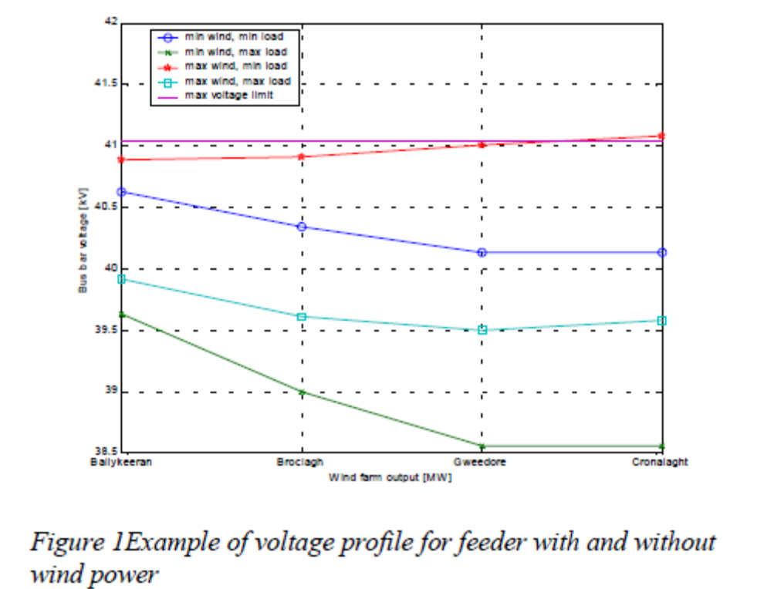
The main problem with wind energy in weak grids is the quasi-static voltage level. In a grid without wind turbines connected the main concern by the utility is the minimum voltage level at the far end of the feeder when the consumer load is at its maximum. So the normal voltage profile for a feeder without wind
energy is that the highest voltage is at the bus bar at the substation and that it drops to reach the minimum at the far end. The settings of the transformers by the utility are usually so, that the voltage at the consumer closest to the transformer will experience a voltage, that is close to the maximum value especially when the load is low and that the voltage is close to the minimum value at the far end when the load is high. This operation ensures that the capacity of the feeder is utilised to its maximum. When wind turbines are connected to the same feeder as consumers which often will be the case in sparsely populated areas the voltage profile of the feeder will be much different from the no wind case. Due to the power production at the wind turbine the voltage level can and in most cases will be higher than in the
no wind case. As is seen on the figure the voltage level can exceed the maximum allowed when the consumer load is low and the power output from the wind turbines is high. This is what limits the capacity of the feeder. The voltage profile of the feeder depends on the line impedance, the point of connection of the wind turbines and on the wind power production and the consumer load. For a simple single load case the voltage rise over the grid impedance can be approximated with ΔU ≅ (R * P + X *Q) /U using generator sign convention. This formula indicates some of the possible solutions to the problem with absorption of wind power in weak grids. The main options are either a reduction of the active power or an increase of the reactive power consumption or a reduction of the line impedance.
Voltage fluctuations

Another possible problem with wind turbines in weak grids are the possible voltage fluctuations as a result of the power fluctuations that comes from the turbulence in the wind and from starts and stops of the wind turbines. As the grids becomes weaker the voltage fluctuations increase given cause to what is termed as flicker. Flicker is visual fluctuations in the light intensity as a result of voltage fluctuations. The human eye is especially sensitive to these fluctuations if they are in the frequency range of 1-10 Hertz. Flicker and flicker levels are defined in IEC1000-3-7, [1]. During normal operation the wind turbulence causes power fluctuations mainly in the frequency range of 1-2 Hertz due to rotational sampling of the turbulence by the blades. This together with the tower shadow and wind shear are the main contributors to the flicker produced by the wind turbine during normal operation.
The other main contribution to the flicker emission is the cut-in of the wind turbine. During cut-in the generator is connected to the grid via a soft starter. The soft starter limits the current but even with a soft starter the current during cut-in can be very high due to the limited time available for cut-in. Especially
the magnetisation current at cut-in contributes to the flicker emission from a wind turbine.
3 Basic Power Control Idea

The main idea is to increase the amount of wind energy that can be absorbed by the grid at a certain point with minimum extra cost. There exist several options that can be implemented in order to obtain a larger
wind energy contribution. These options include:
Grid reinforcement
Voltage dependent disconnection of wind turbines
Voltage dependent wind power production
Inclusion of energy buffer (storage)

Determination of actual voltage distribution instead of worst case and evaluation if real conditions will be a problem Grid reinforcement increases the capacity of the grid by increasing the cross section of the cables. This is usually done by erecting a new line parallel to the existing line for some part of the distance. Because of the increased cross section the impedance of the line is reduced and therefore the voltage variations as a result of power variations are reduced. Grid reinforcement increases both the
amount of wind energy that can be connected to the feeder and the maximum consumer load of the feeder. Since the line impedance is reduced the losses of the feeder are also reduced. Grid reinforcement can be very costly and sometimes impossible due to planning restrictions. Since grid reinforcement can be very costly or impossible other options are interesting. The most simple alternative is to stop some of the wind turbines when the voltage level is in danger of being exceeded. This can e.g. be done by the wind turbine controller monitoring the voltage level at the low voltage side of the connection point. At a certain level the wind turbine is cut off and it is then cut in again when the voltage level is below a certain limit. The limits can be precalculated and depends on transformer settings, line impedance and other loads of the feeder. This is a simple and crude way of ensuring that the voltage limits will not be exceeded. It can be implemented at practically no cost but not all the potentially available wind energy is utilised.
A method that is slightly more advanced is to continuously control the power output of the wind turbine in such a way that the voltage limit is not exceeded. This can be done on a wind farm level with the voltage measured at the point of common connection. The way of controlling the power output requires that the wind turbine is capable of controlling the output (pitch or variable speed controlled) and a bit more sophisticated measuring and control equipment, but the amount of wind energy that is dumped is reduced compared to the option of switching off complete wind turbines. The basic power control idea in the current context of this project is based on the combination on wind turbines and some kind of energy storage. The storage is used to buffer the wind energy that cannot be feed to the grid at the point of connection without violating the voltage limits. Usually the current limit of the grid will not be critical. The energy in the storage can then be fed back to the grid at a later time when the voltage level is lower.
The situations where the voltage level will be high will occur when the consumer load of the grid is low and the wind power production is high. If the voltage level will be critically high depends on the characteristics of the grid (e.g. impedance and voltage control), the minimum load of the consumers, the
amount of installed wind power and the wind conditions. The critical issues involved in the design of a power control system are the power and energy capacity, the control bandwidth as well as investment, installation and maintenance cost. The various types of power control systems have different characteristics giving different weights on capacity, investment and maintenance. Different types of storage can be applied. During the project only pumped storage and batteries has been investigated. Other types of storage include flywheel, super conducting magnetic storage, compressed air and capacitors. These types of storage have not been investigated for several reasons among them cost, capacity
and availability.

Control Strategies

Several different control strategies exist for a power controller with storage. The different control strategies place different weights on voltage and power fluctuations and therefore have different impact on the sizing of the storage capacity and of the power rating. The two main types of control strategies are ones controlling the voltage at the point of common connection or another point in the grid and the ones controlling the power for smoothing or capacity increase.

4.1 Voltage peak limitation

The first control strategy is to limit the number of occurrences of voltage excursions above the upper voltage limit by absorbing the excess power in the storage. Since the probability of overvoltage is higher at certain times of the day one possible control strategy is to start up e.g. a pumped storage plant at the beginning of such a period and then let it run pumping water up to the upper reservoir during that period at a certain power level that will ensure that overvoltages will only occur very seldom. The period could be 4-5 hours during the night. The stored energy could then be released during high load periods e.g. during the evening. The rating of the pumps and the capacity of the reservoir have to be sized to accommodate for the power and energy requirements but the control would be very simple. The size of the reservoir would have to be quite large since it would have to accommodate the large amount of energy that has to be absorbed during a relatively long period of time and since there is no feed back whether the voltage is high or not. The control of the system will be extremely simple since all it requires is a start signal and a stop signal. It will also involve only proven technology. In order to reduce the required reservoir size measurement of the grid voltage can be included in the control of the system. Now the system will only start up if the voltage exceeds a certain level and it will shut down if the voltage is below
a certain other value. Depending on the technology the limits for starting and stopping the plant can be close to the voltage limit or a bit away from the limit. So now storage capacity is only needed when the voltage is high. If the storage is large enough as well as the power rating this system can eliminate
overvoltages. In order to be able to estimate the required size some kind of simulation tool is needed that can take the stochastic nature of both the wind and the load into consideration.
4.2 Voltage control

Limiting the maximum voltage level is very important but sometime more accurate control is desired. This can include maintaining the voltage level and reduce flicker. When these features are implemented the total system, wind farm and power control plant, will be an active part of the power supply system.
Some of the reasons behind this can be a desire to improve the general power quality of the area and eliminate the impact of wind energy on the voltage. When the control strategy is to maintain the voltage level and reduce flicker the power control plant has to be active all the time. The requirements to the size of the storage is increased since it now should be able to supply energy in large amounts during low voltage situations and also the requirements to handle fast variations are increased since flicker is in the range up to 15 Hz. The plant will also be able to supply and absorb reactive power. Again simulation models are needed These will have to be able to estimate the size of both the power and the storage as well as the dynamic performance if flicker is to be eliminated.
4.3 Power Fluctuations
Instead of controlling the voltage at the point of connection another control parameter could be the output power from a wind farm. The objective can e.g. be to keep the output power as constant as possible. This will eliminate voltage fluctuations generated by the wind farm and therefore also flicker. Another
benefit by this way of controlling the total system, wind farm and power controller, is that the impact on the other generating components is very limited and the stochastic nature of the wind power is reduced.
Since it will require a very large storage system to keep the output constant at all times it will be more realistic to let the output of the total system vary slowly with the mean wind energy production . This will still make the wind energy seem more firm since the variations are more slow and therefore more stable. It will also reduce the flicker since the fast variations in the output power from the wind farm are absorbed by the storage system. The reactive power can be controlled in the same way. The only difference is that control of the reactive power does only require a very minimal storage capacity.
The requirements to the bandwidth of the power controller hardware are relatively high if all fluctuations causing flicker are to be eliminated. Modern power electronics will be able to obtain the required bandwidth.
4.4 Firm power

As for the previous strategy one of the objectives can be to supply firm power. Firm power is here understood to be power that can be scheduled. In connection with wind power and weak grids important aspects are the ability to inject power during high load periods thus reducing the requirements for conventional capacity and reducing the impact of voltage drop on the feeder during the same high load periods. A firm power strategy will be an additional strategy since it on its own will not reduce the voltage level during high voltage periods. In order to be able to inject power into the power system when it is required it is necessary that the storage has enough energy stored. It is clear that because 12 Risø-R-1118(EN) some of the capacity of the storage is already taken up by the need to be able to supply power when required either the storage capacity has to be increased if the same level of overvoltage probability is desired or there will be an increase in overvoltage probability.
4.5 Tariff control
Tariff control is like firm power control an additional control strategy. The idea is that the storage is filled during periods with a low tariff and the energy is release when the tariff is high. If there is a large difference between the low and high tariff additional money can be earned by the plant owner. As for the firm power control strategy there is a probability that a overvoltage will occur when the storage is filled due to the transferring of energy from low tariff periods to high tariff periods either the storage has to be increased or the overvoltage probability will increase. Another aspect of the Tariff control strategy is that it has to be remembered that significant amounts of energy are lost in the conversion (20-30%).
5 Power Control Concepts
As described above there exist several control strategies for power controllers. When they are combined with different types of storage systems several different kinds of power control concepts exist. The main options studied in the current project concerns pumped storage and batteries combined with control strategies that are based on the natural strength of the two storage types.

5.1 Pumped storage concept
In a pumped storage power control system a system with two water reservoir with a head difference is used as storage. Water is pumped from the lower hea to the higher head when power has to be absorbed and it is released through a turbine when the grid can absorb the stored energy.
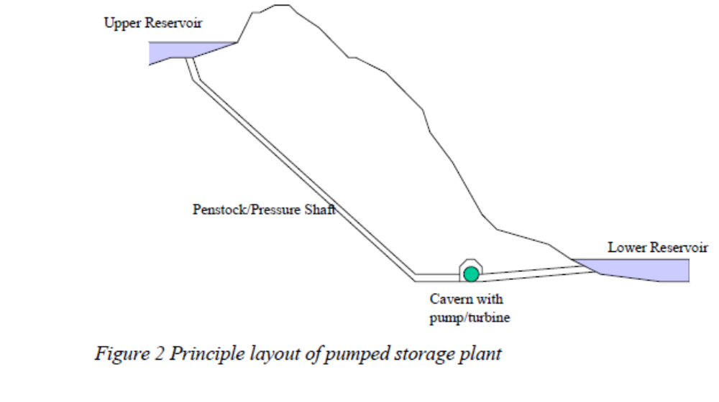The principal components of the pumped storage system are (Figure 2)
Upper reservoir
Lower reservoir
Pressure shaft (Penstock)
Turbine/Pump house
Turbine
Pump
Generator
Motor
Control system

The two reservoirs can be two lakes situated close to each other or it can be an artificial reservoir as the upper reservoir and natural lake as the lower or it can be an artificial reservoir as the upper reservoir with the sea acting as the other reservoir. In the last case the water being pumped and stored will of course be
saltwater. The construction of the upper reservoir will then have to take that into account so that the salty water does not leak through the bottom of the reservoir and pollute the ground and the ground water with salt. It is also important the turbine, pump and pressure shaft are constructed to handle saltwater. The difference in head between the two reservoirs determines together with the dimensions of the pressure shaft the power that is available. The capacity of the storage is determined by the change in head from full to empty, the area of the reservoir and difference in head between the two reservoirs. The conversion from kinetic energy of the falling water to electrical energy takes place in the turbine/generator arrangement in the turbine/pump house. There exist different types of turbines with different features. In order to save investment it is desirable to use a turbine type that is good both as a turbine and as a pump.
As for the turbine/pump it is desirable to have only one generator/motor per turbine/ pump. There are two basic choices for generator, synchronous and induction generators. For larger plant synchronous generators will be the natural choice since the plant will look very much like a conventional hydro plant with the same possibilities to participate in the voltage control of the grid. For small plants induction machines could be an alternative. The control system implements the desired control strategy and manages changes in power flow direction and prevents components from being overloaded. The bandwidth of the pumped storage plant is sufficient to eliminate the lower frequency fluctuations thus eliminating the over-voltage situations. It is not desirable to have the plant to eliminate flicker. This is for control reasons in order not to put too much load on the speed controller and voltage controller. The start up time and the time it takes to reverse the power flow are rather long. The start up time is in the range of 1 minute and the power reversal time is in the range of 8-10 minutes. 14 Risø-R-1118(EN)
The overall efficiency is approx. 75% taking losses in the motor/generator, turbine and the hydraulic part into account. Pumped storage plants integrate very well with the conventional power system. This is due to the fact that it is build as a hydro plant with the exception that it can also pump water and therefore absorb energy. The possibilities for control of the power and the voltage are the same as for a hydro plant and it can therefore be treated in the same way. Pumped storage systems will typically be rather large compared to systems with batteries or flywheels. This is due to the high cost of establishing the pressure
shaft and the reservoir, both costs being relatively insensitive to the size of the plant. This means that it in order to decrease the specific investment the plants will be large. This can be seen in Table 1 where there is a clear tendency for lower cost at larger plant sizes.

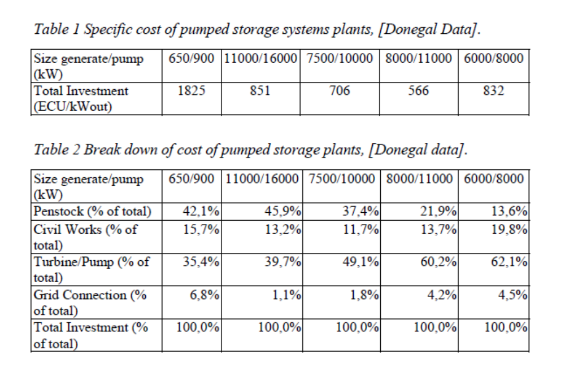
In Table 2 is a break down of the cost of different cost estimates for pumped storage plants studied in the Donegal Case Study of the project. It is clear from these data that the penstock is a very significant part of the total cost, but it is also evident that the distribution of the cost depends very strongly on local conditions. This can be seen in Table 3 where the specific cost of the penstock is shown.
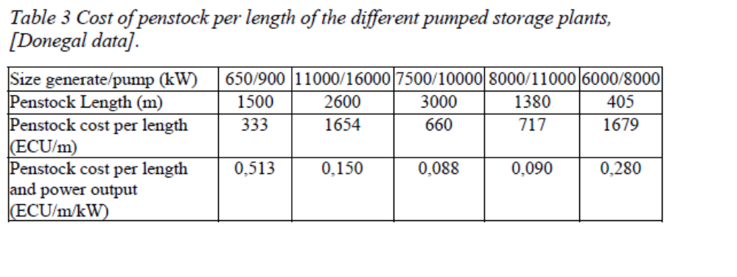
The main advantages of a pumped storage system compared with the other types of storage are that the technology is well known and proven and that the energy capacity will usually be quite large and not very sensitive to the investment cost. The operating and maintenance cost will usually be low compared
with other types. The initial investments costs of a pumped storage system are high due to especially
the penstock cost. If the reservoirs have to be made artificially the cost of that can also be very high. In order to keep costs down it can be very beneficial to combine a pumped storage plant with a conventional plant or to see the pumped storage plant as a capacity expansion. A limitation of the pumped storage concept is also that it is very dependent on the available sites. If the situation changes and e.g. a new feeder is installed eliminating the capacity problems of the existing feeder the value of a pumped
storage plant will be much lower since it cannot be moved. The capacity of the plant is also quite fixed since it is difficult or expensive to expand the capacity.

- SYSTEM DESCRIPTION AND MODELLING

- System description

Fig.1 depicts the power system under consideration in this study. The WF is composed by 36 wind turbines using squirrel cage induction generators, adding up to 21.6MW electric power. Each turbine has attached fixed reactive compensation capacitor banks (175kVAr), and is connected to the power grid via 630KVA 0.69/33kV transformer. This system is taken from
[7], and represents a real case. The ratio between short circuit power and rated WF power,
give us an idea of the “connection weakness”. Thus considering that the value of short circuit power in MV6 is SSC ≃ 120MV A this ratio can be calculated:

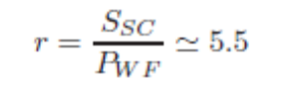
Values of r < 20 are considered as a “weak grid” connection [2].

B. Turbine rotor and associated disturbances model

The power that can be extracted from a wind turbine, is determined by the following expression:
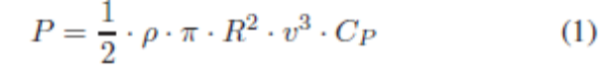
Where _ is air density, R the radius of the swept area, v the wind speed, and CP the power coefficient. For the considered turbines (600kW) the values are R = 31.2 m , _ = 1.225 kg/m3 and CP calculation is taken from [8]. Then, a complete model of the WF is obtained by turbine
aggregation; this implies that the whole WF can be modeled by only one equivalent wind turbine, whose power is the arithmetic sum of the power generated by each turbine according
to the following equation:
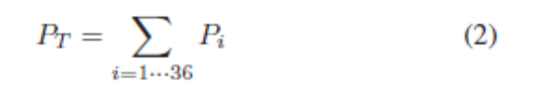
Moreover, wind speed v in (1) can vary around its average value due to disturbances in the wind flow. Such disturbances can be classified as deterministic and random. The firsts are caused by the asymmetry in the wind flow “seen” by the turbine blades due to “tower shadow” and/or due to the atmospheric boundary layer, while the latter are random changes known as “turbulence”. For our analysis, wind flow disturbance due to support structure (tower) is considered, and
modeled by a sinusoidal modulation superimposed to the mean value of v. The frequency for this modulation is 3 ・Nrotor for the three–bladed wind turbine, while its amplitude depends on the geometry of the tower. In our case we have considered a mean wind speed of 12m/s and the amplitude modulation of 15%. The effect of the boundary layer can be neglected compared to those produced by the shadow effect of the tower in most cases [3]. It should be noted that while the arithmetic sum of perturbations occurs only when all turbines operate synchonously and in phase, this is the case that has the greatest impact on the power grid (worst case), since the power pulsation has maximum amplitude. So, turbine aggregation method is valid.

C. Model of induction generator

For the squirrel cage induction generator the model available in Matlab/Simulink SimPowerSystemsc libraries is used. It consists of a fourth–order state–space electrical model and a second–order mechanical model [5].

D. Dynamic compensator model

The dynamic compensation of voltage variations is performed by injecting voltage in series and active–reactive power in the MV6 (PCC) busbar; this is accomplished by using an unified type compensator UPQC [9]. In Fig.2 we see the basic outline of this compensator; the busbars and impedances numbering is referred to Fig.1. The operation is based on the generation of three phase voltages, using electronic converters either voltage source type (VSI–Voltage Source Inverter) or current source type (CSI– Current Source Inverter). VSI converter are preferred because of lower DC link losses and faster response in the system than CSI [9]. The shunt converter of UPQC is responsible for injecting current at PCC, while the series converter generates voltages between PCC and U1, as illustrated in the phasor diagram of Fig.3. An important feature of this compensator is the operation of both VSI converters (series and shunt) sharing.
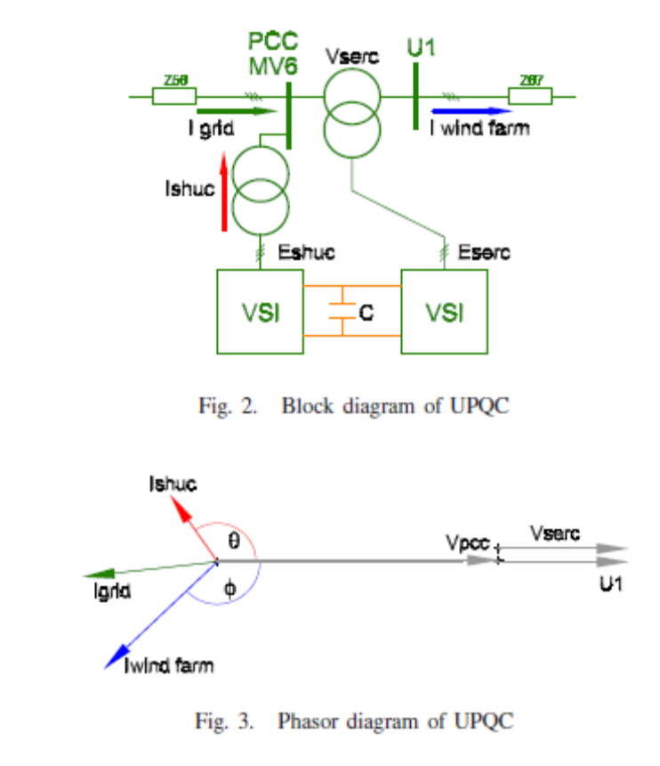
the same DC–bus, which enables the active power exchange between them. We have developed a simulation model for the UPQC based on the ideas taken from [10]. Since switching control of
converters is out of the scope of this work, and considering that higher order harmonics generated by VSI converters are outside the bandwidth of significance in the simulation study, the converters are modelled using ideal controlled voltage sources. Fig.4 shows the adopted model of power side of UPQC. The control of the UPQC, will be implemented in a rotating frame dq0 using Park’s transformation (eq.3-4)

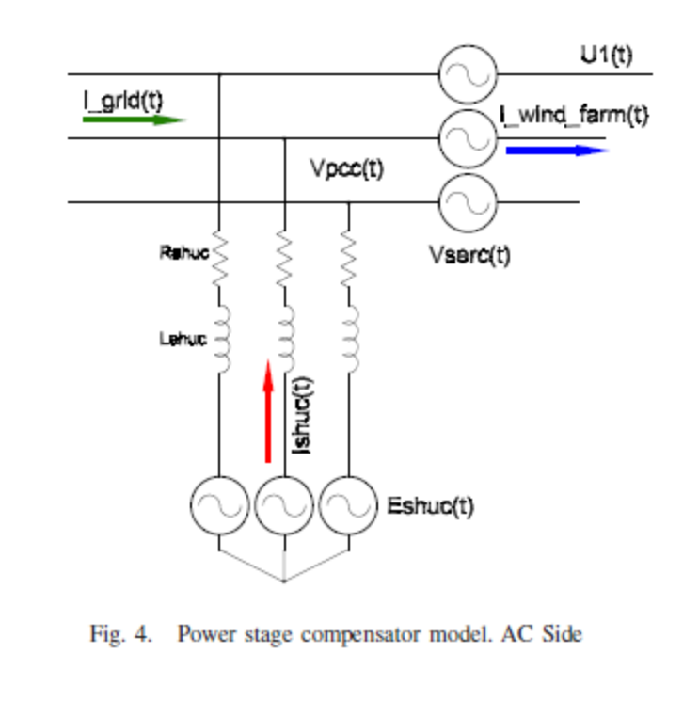
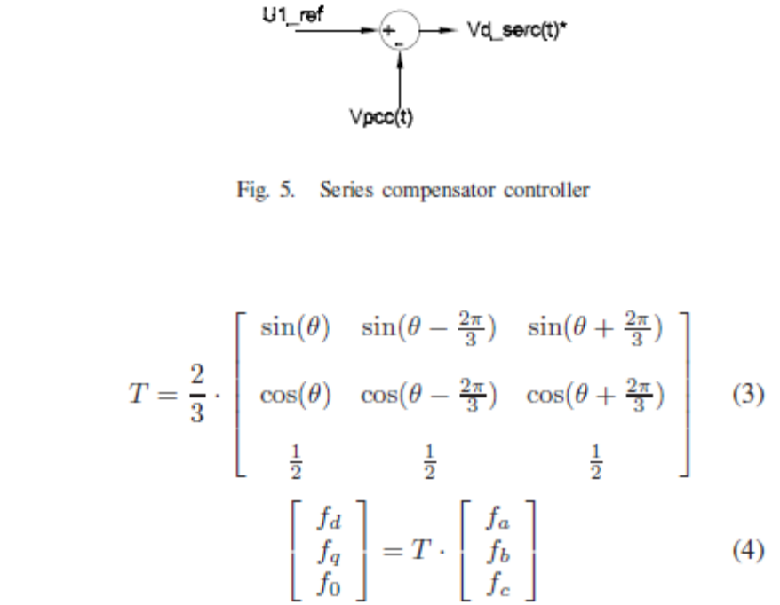
Wherefi=a,b,c represents either phase voltage or currents, and fi=d,q,0 represents that magnitudes transformed to the dqo space. This transformation allows the alignment of a rotating
reference frame with the positive sequence of the PCC voltages space vector. To accomplish this, a reference angle _ synchronized with the PCC positive sequence fundamental voltage space vector is calculated using a Phase Locked Loop (PLL) system. In this work, an “instantaneous power theory” based PLL has been implemented [11]. Under balance steady-state conditions, voltage and currents vectors in this synchronous reference frame are constant quantities. This feature is useful for analysis and decoupled control.

- UPQC CONTROL STRATEGY

The UPQC serial converter is controlled to maintain the WF terminal voltage at nominal value (see U1 bus-bar in Fig.4), thus compensating the PCC voltage variations. In this way, the voltage disturbances coming from the grid cannot spread to the WF facilities. As a side effect, this control action may increase the low voltage ride–through (LVRT) capability in the occurrence of voltage sags in the WF terminals [4], [9]. Fig.5 shows a block diagram of the series converter controller. The injected voltage is obtained substracting the PCC voltage from the reference voltage, and is phase–aligned with the PCC voltage (see Fig.3). On the other hand, the shunt converter of UPQC is used to filter the active and reactive power pulsations generated by the WF. Thus, the power injected into the grid from the WF compensator set will be free from pulsations, which are the origin of voltage fluctuation that can propagate into the system. This task is achieved by appropiate electrical currents injection in PCC. Also, the regulation of the DC bus voltage has been assigned to this converter. Fig.6 shows a block diagram of the shunt converter controller. This controller generates both voltages commands
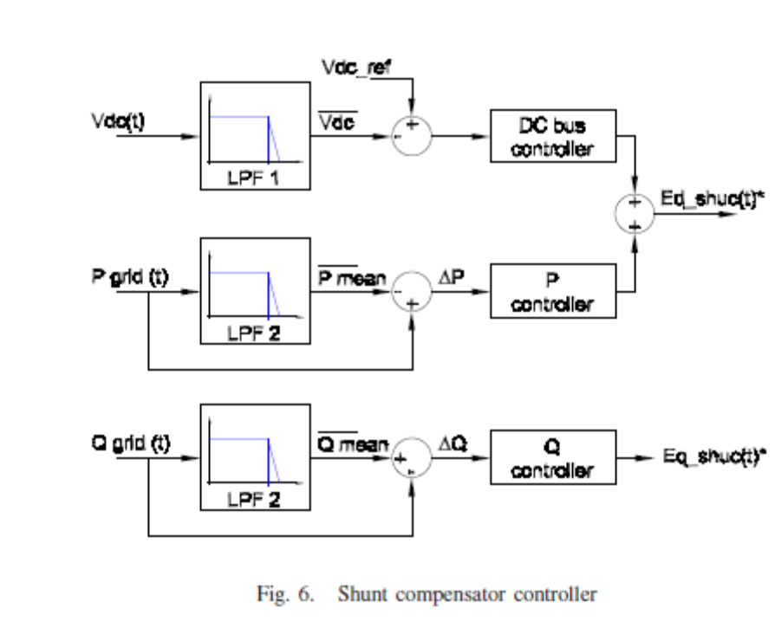
Ed shuC ∗ and Eq shuC ∗ based on power fluctuations _P and Q, respectively. Such deviations are calculated substracting the mean power from the instantaneus power measured in PCC.
The mean values of active and reactive power are obtained by low–pass filtering, and the bandwidth of such filters are chosen so that the power fluctuation components selected for
compensation, fall into the flicker band as stated in IEC61000- 4-15 standard. In turn, Ed shuC ∗ also contains the control action for the DC–bus voltage loop. This control loop will not interact with the fluctuating power compensation, because its components are lower in frequency than the flicker–band. The powers PshuC and QshuC are calculated in the rotating reference frame, as follows:
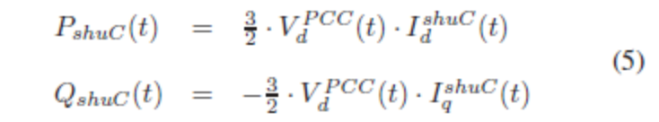
Ignoring PCC voltage variation, these equations can be
written as follows.
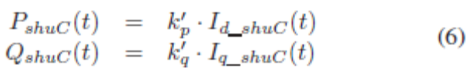
Taking in consideration that the shunt converter is based on a VSI, we need to generate adecuate voltages to obtain the currents in (6). This is achieved using the VSI model proposed sin [10], leading to a linear relationship between the generated power and the controller voltages. The resultant equations are:
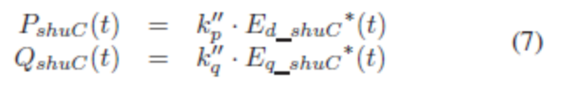
P and Q control loops comprise proportional controllers, while DC–bus loop, a PI controller.
In summary, in the proposed strategy the UPQC can be seen as a “power buffer”, leveling the power injected into the power
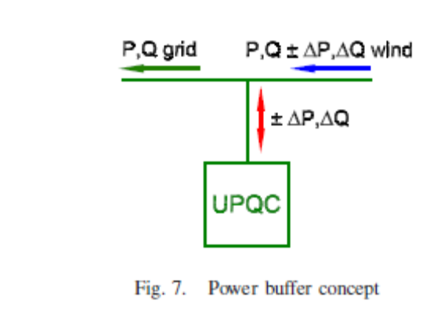
system grid. The Fig.7 illustrates a conceptual diagram of this mode of operation. It must be remarked that the absence of an external DC source in the UPQC bus, forces to maintain zero–average power in the storage element installed in that bus. This is accomplished by a proper design of DC voltage controller. Also, it is necessary to note that the proposed strategy cannot
be implemented using other CUPS devices like D–Statcom or DVR. The power buffer concept may be implemented using a DStatcom, but not using a DVR. On the other hand, voltage regulacion during relatively large disturbances, cannot be easily coped using reactive power only from DStatcom; in this case, a DVR device is more suitable.

REFERENCES

[1] M.P. P´alsson, K. Uhlen, J.O.G. Tande. “Large-scale Wind Power Integration and Voltage Stability Limits in Regional Networks”; IEEE 2002. p.p. 762–769
[2] P. Ledesma, J. Usaola, J.L. Rodriguez “Transient stability of a fixed speed wind farm” Renewable Energy 28, 2003 pp.1341–1355
[3] P. Rosas “Dynamic influences of wind power on the power system”. Technical report RISØR-1408. Ørsted Institute. March 2003.
[4] R.C. Dugan, M.F. McGranahan, S. Santoso, H.W. Beaty “Electrical Power Systems Quality” 2nd Edition McGraw–Hill, 2002. ISBN 0-07- 138622-X
[5] P. Kundur “Power System Stability and Control” McGraw-Hill, 1994. ISBN 0-07-035958-X
[6] N. G. Hingorani y L. Gyugyi. “Understanding FACTS”. IEEE Press; 2000.
[7] Z. Saad-Saoud, M.L. Lisboa, J.B. Ekanayake, N. Jenkins and G. Strbac “Application of STATCOM’s to wind farms” IEE Proc. Gen. Trans. Distrib. vol. 145, No. 5; Sept. 1998
[8] T. Burton, D. Sharpe, N. Jenkins, E. Bossanyi “Wind Energy Handbook” John Wiley & Sons, 2001. ISBN 0-471-48997-2.
[9] A. Ghosh, G. Ledwich “Power Quality Enhancement Using Custom Power Devices” Kluwer Academic Publisher, 2002. ISBN 1-4020-7180- 9
[10] C. Schauder, H. Mehta “Vector analysis and control of advanced static VAR compensators” IEE PROCEEDINGS-C, Vol.140, No.4, July 1993.
[11] E.M. Sasso, G.G. Sotelo, A.A. Ferreira, E.H. Watanabe, M. Aredes, P.G. Barbosa, “Investigac¸ ˜ao dos Modelos de Circuitos de Sincronismo Trif´asicos Baseados na Teoria das Potˆencias Real e Imagin´aria Instantaneas (p–PLL e q–PLL)”, In: Proc. (CDROM) of the CBA 2002 – XIV Congresso Brasileiro de Automtica, pp. 480-485, Natal RN, Brasil, 1-4, Sep. 2002
[12] International Electrotechnical Commission ”INTERNATIONAL STANDAR IEC 61000-4-15: Electromagnetic compatibility (EMC) Part 4: Testing and measurement techniques Section 15: Flickermeter Functional and design specifications.” Edition 1.1 2003
[13] H. Akagi, E. H. Watanabe, M. Aredes “Instantaneous power theory an applications to power conditioning”, John Wiley & Sons, 2007. ISBN 978-0-470-10761-4.

